- Configure VPC endpoints to securely access AWS services without internet gateways or NAT gateways, ensuring data privacy and minimizing exposure to external threats.
I configured the VPC, two subnets, two route tables, One IGW for public subnet (Internet Access) & Two Instances.
I created one s3 bucket for configure the VPC endpoint connection.
Basically, VPC endpoint will help us to connect private subnet instances to other AWS services without any internet within the VPC.
So, I am configuring one VPC endpoint (endpoint-task) with the service name S3. (we chosen the S3 service). There we have two type of endpoints – 1.) Interface 2.) Gateway.
Gateway is easy process, If we chosen Interface it will create one ENI .
Without routing it will not work. So, we are routing this Endpoint connection in private route table. Because we are trying to route the private subnet instance to S3 service.
At last, we are able to access the service through aws s3 ls –profile=default
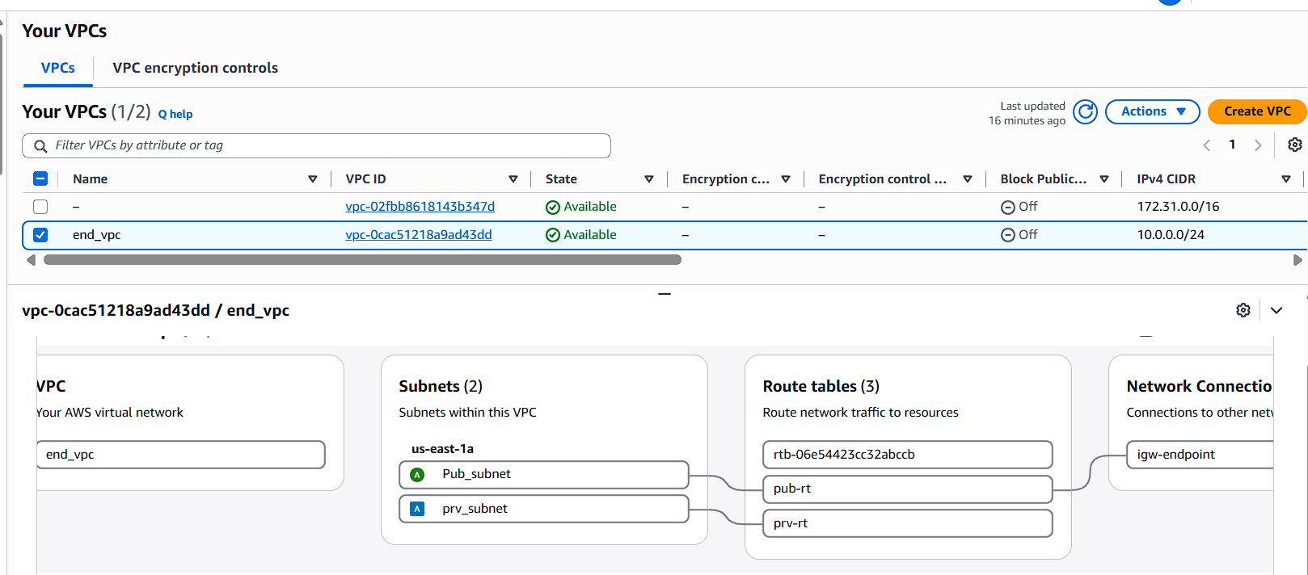
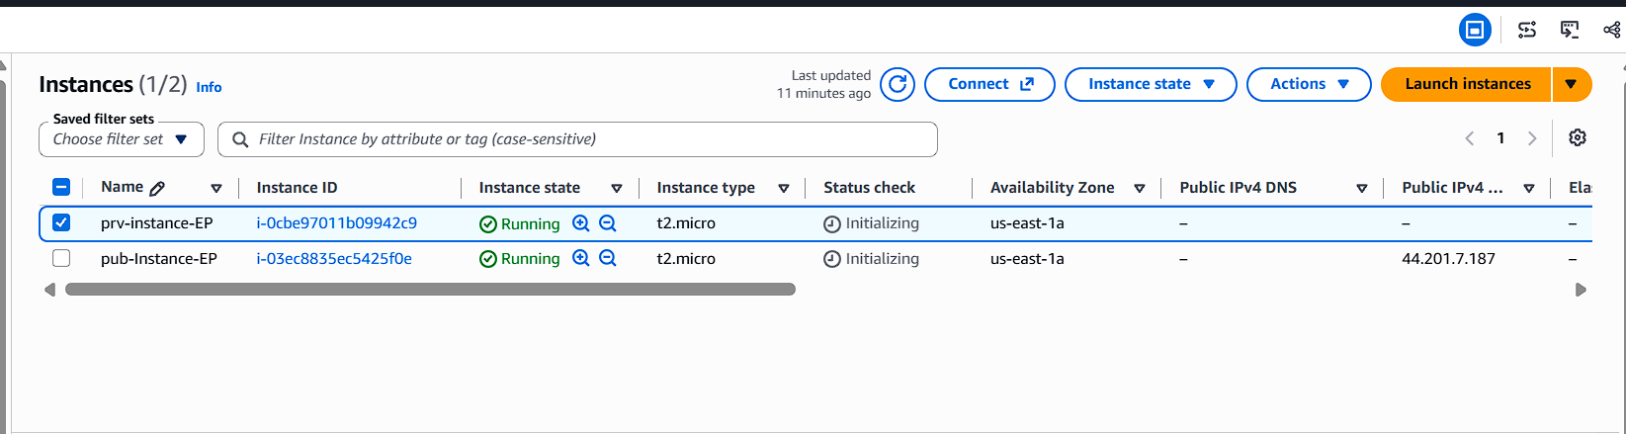
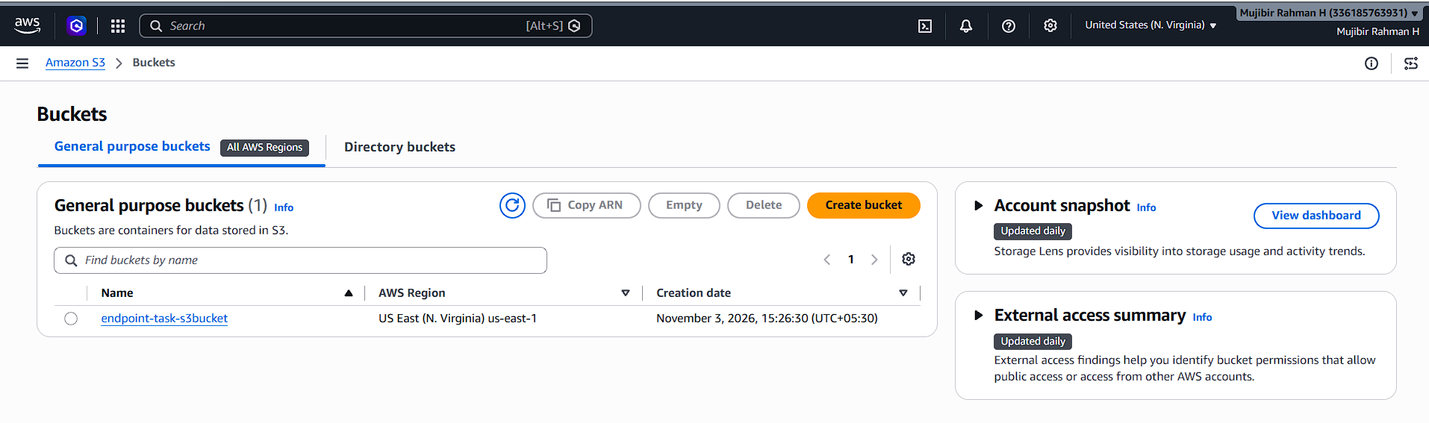
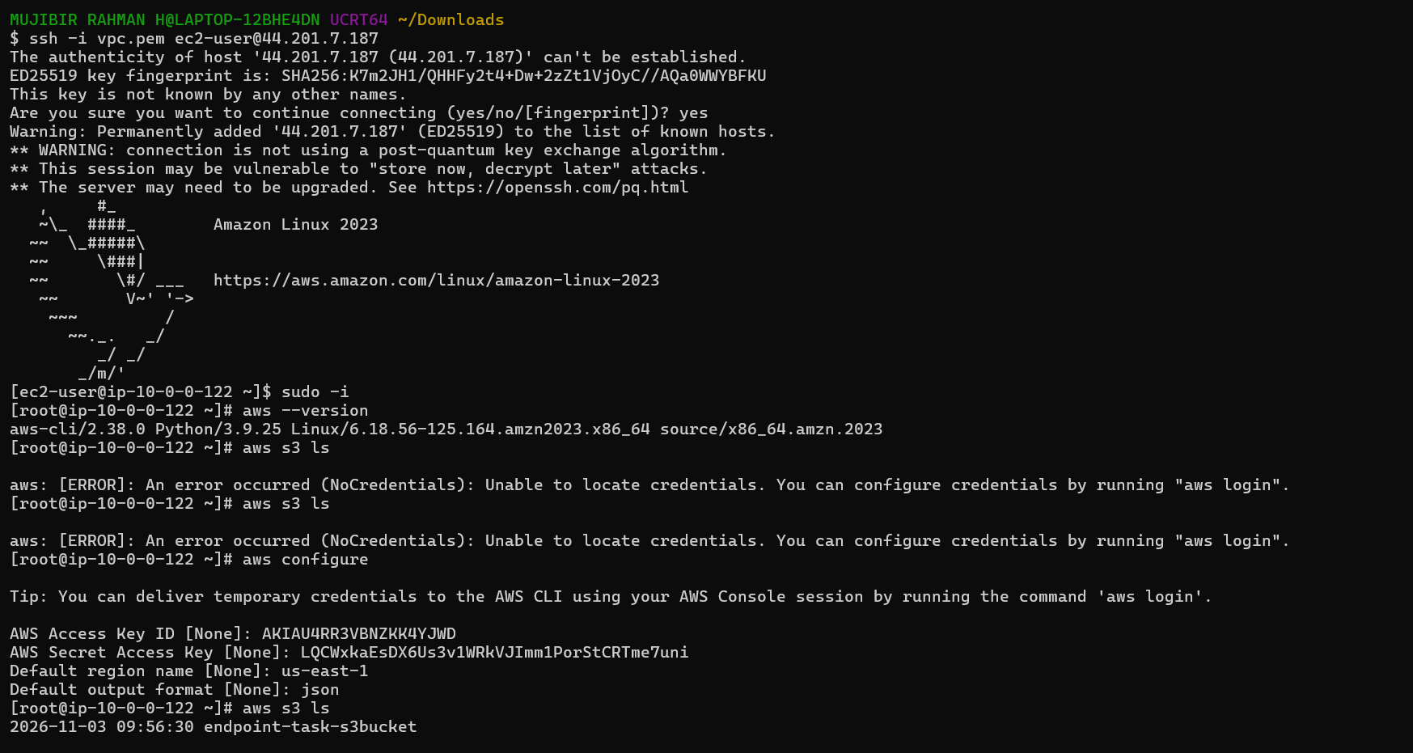
Private
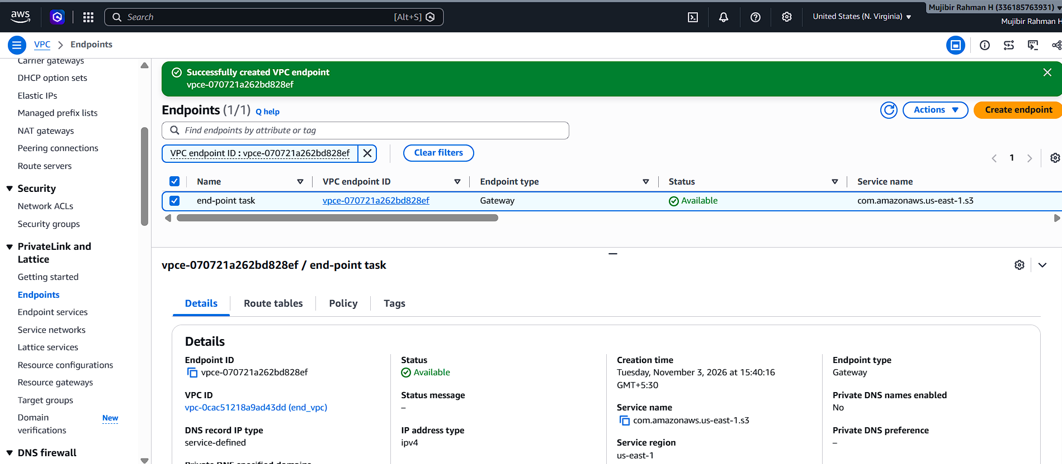
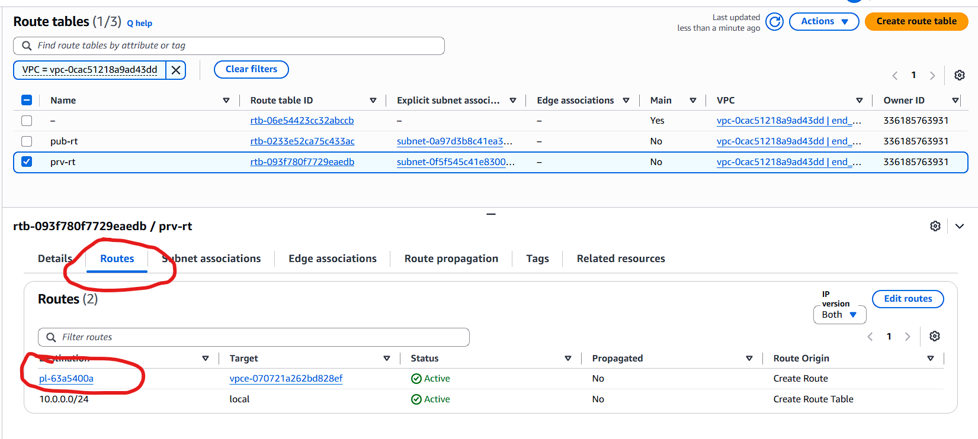
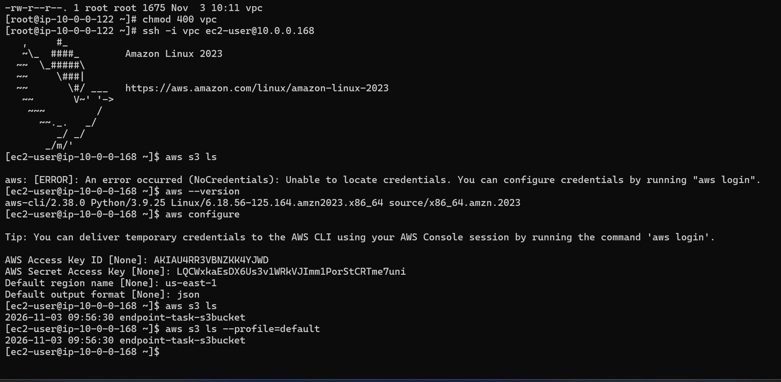
- Design and deploy a scalable network architecture using AWS Transit Gateway to simplify network connectivity between multiple VPCs.
We are configuring the networking. Means, Multiple VPC’s, subnets (each VPC one subnet, route tables).
Basically, Transit Gateway will help us to connect/communicate to multiple VPC’s (more number of VPC’s 50/100). We can use TGW instead of peering connection. But it’s totally depending on organization budget.
Because, TGW method is costlier than peering connection.
Configure Transit gateway.
TGW attachment –Nothing but we need to attach all the VPC’s.
We have option for auto-creation TGW route gateway. It will automatically enable the TGW Route tables for TGW attachments.
Finally, we need to configure the CIDR in VPC route tables. ( In VPC1, I am configuring routes means need to give VPC2, VPC3 and default).
Now try to access from default instance to other VPC’s. It’s working.
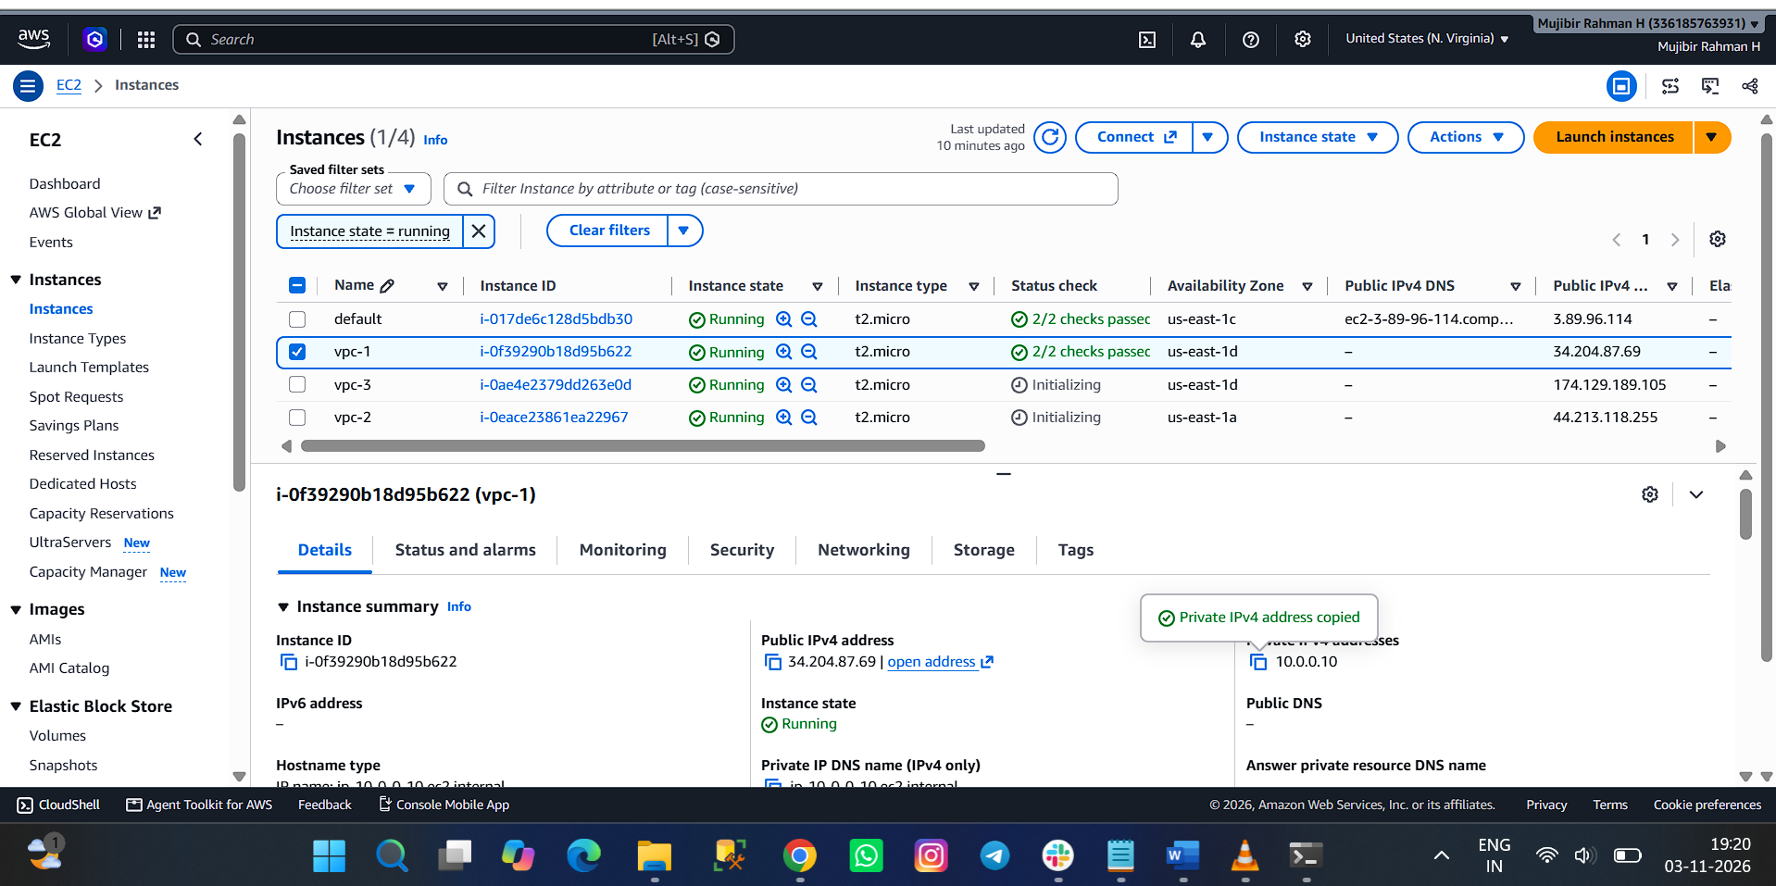
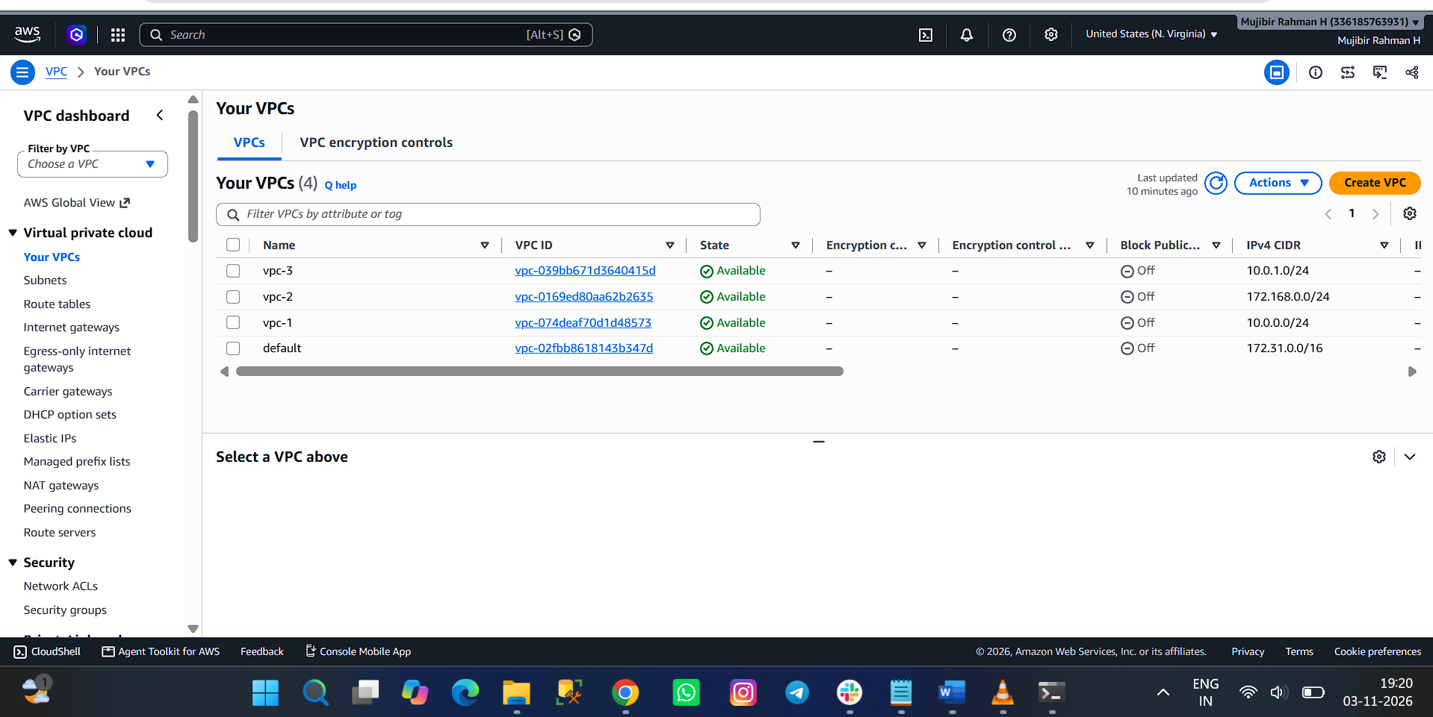
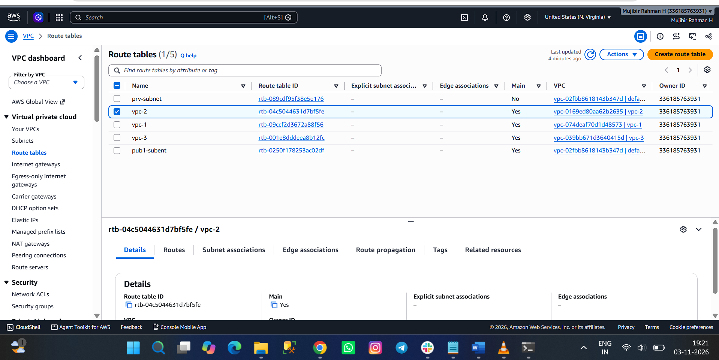
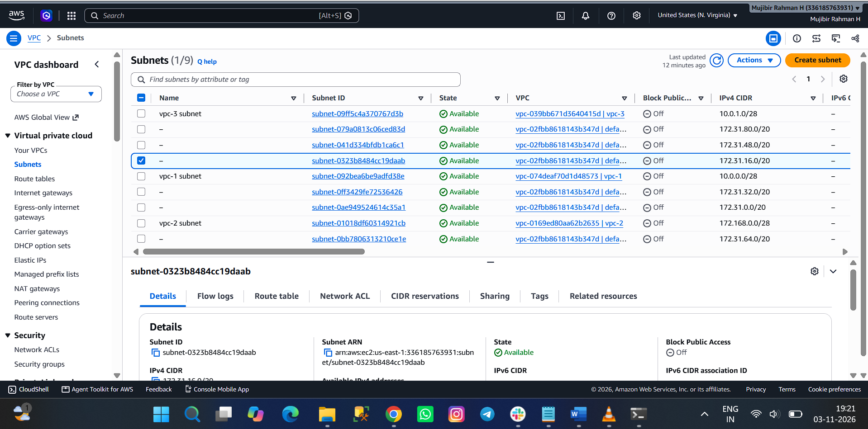
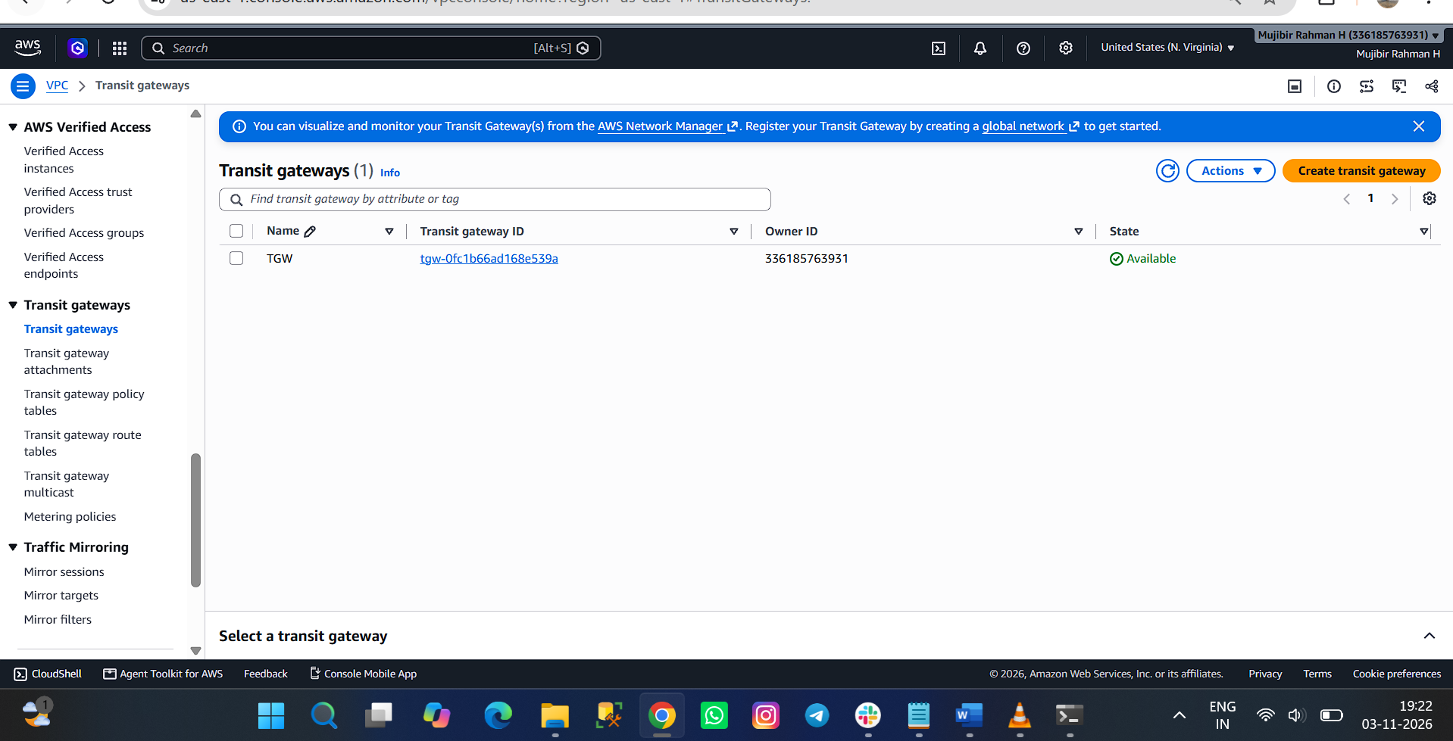
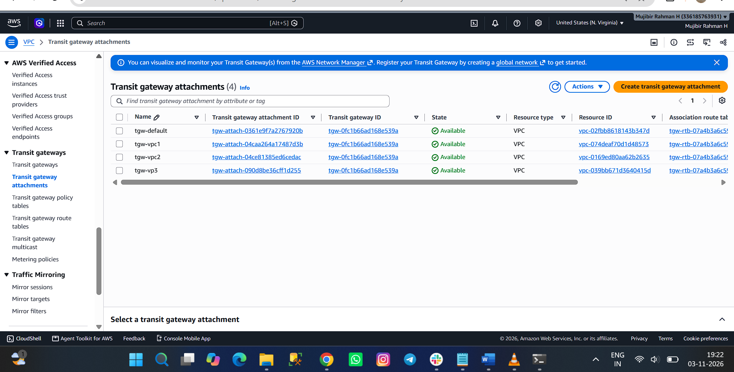
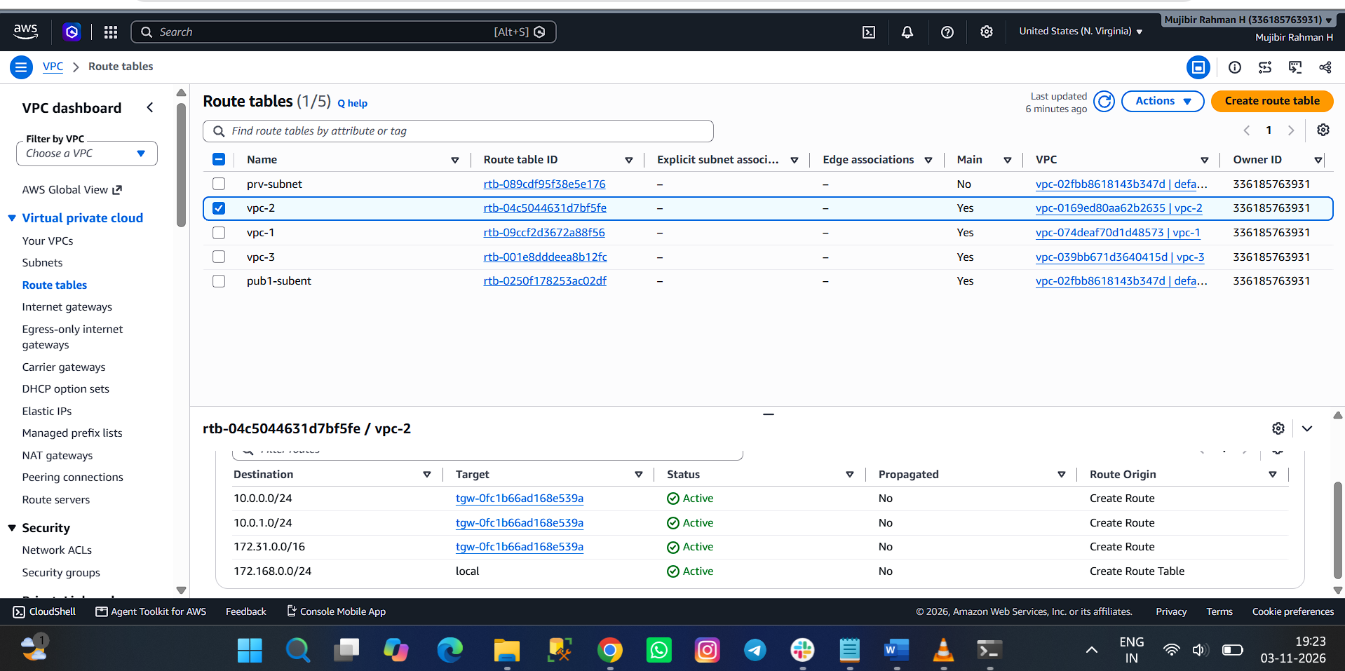
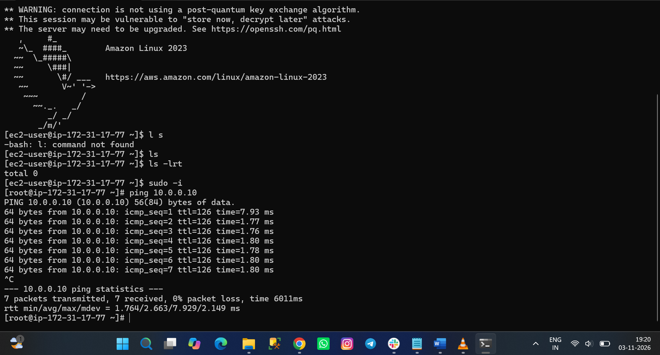
Vpc -1 from default instance- it’s working.


